**SMART CAR PARKING SYSTEM**

A PROJECT REPORT

***Submitted by***

# POOJAA.S 113220051019

**VARSHINI.T 113220051032**

**in partial fulfillment for the award of the degree**

***of***

# BACHELOR OF ENGINEERING

***in***

## ELECTRICAL AND ELECTRONICS ENGINEERING

**VELAMMAL ENGINEERING COLLEGE , CHENNAI**

**ANNA UNIVERSITY : CHENNAI 600025**

**MAY 2022**

**BONAFIDE CERTIFICATE**

Certified that this project report **“SMART CAR PARKING SYSTEM”** is the bonafide work of **“POOJAA.S AND VARSHINI.T”,** who carried out the

project work under my supervision .

## SIGNATURE SIGNATURE

**Dr.R.UMAMAHESWARI Dr.R.UMAMAHESWARI**

## HEAD OF THE DEPARTMENT SUPERVISOR

**ASSISTANT PROFESSOR-II**

Electrical and Electronics Engineering Electrical and Electronics Engineering Engineering

Velammal Engineering College Velammal Engineering College

Chennai-600 066. Chennai - 600 066.

**CERTIFICATE OF EVALUATION**

**College Name :** 1132 Velammal Engineering College

**Branch & Semester :** Electrical and Electronics Engineering / IV

|  |  |  |
| --- | --- | --- |
| **NAME OF THE STUDENTS** | **TITLE OF THE PROJECT** | **PROJECT GUIDE** |
| **POOJAA.S**  **VARSHINI.T** | SMART CAR SMART PARKING SYSTEM | Dr.R.UMAMAHESWARI  ASST.PROF.II |

The report of the project work submitted by the above students in partial fulfillment for the award of Bachelor of Engineering degree in ELECTRICAL AND ELECTRONICS ENGINEERING of Anna University was confirmed to be report of the work done by the above students and then evaluated.

**INTERNAL EXAMINER EXTERNAL EXAMINER**

ACKNOWLEDGEMENT

We express our sincere thanks to **Shri.M.V.Muthuramalingam,** Chairman and **Mr.M.V.M.Velmurugan,** Chief Executive Officer of Velammal Engineering College for their support during our project work.

We thank **Dr.S,Satish Kumar,** Principal, Velammal Engineering College for his motivation and support during the course of the project.

We are very much grateful to **Dr.R.Umamaheswari**, Professor and Head, Department of Electrical and Electronics Engineering, Velammal Engineering College for the encouragement and useful suggestions during this work.

We are very much indebted to our Internal Guide, **Dr.R.Umanaheswari** Department of Electrical and Electronics Engineering, Velammal Engineering College for his admirable guidance and constant encouragement throughout the project work.

We would like to extend our fullest gratitude to our Project Coordinator, **Dr.R.Umamaheswari** and project review committee for their timely advice and successful grooming.

We take this opportunity to thank our parents, all faculty and staff of our department for their kind help during the course of work.

**TABLE OF CONTENTS**

|  |  |  |
| --- | --- | --- |
| **CHAPTER NO** | **TITLE** | **PAGE NO** |
| 1. | **ABSTRACT** | **4** |
| 2. | **INTRODUCTION** | 5 |
| 3. | **CIRCUIT DIAGRAM** | 6 |
| 3.0 | Block Diagram | 6 |
| 3.1 | Introduced mechanism |  |
| 3.2 | Hardware used | 7 |
| 3.2.1 | Arduino uno | 7 |
| 3.2.2 | IR sensor | 7 |
| 3.2.3 | Servomotor | 8 |
| 3.2.4 | Lithium Ion Battery | 8 |
| 3.2.5 | LCD display |  |
| 4. | **SOFTWARE** | 9 |
| 4.0 | Software used | 9 |
| 4.0.1 | Arduino uno | 9 |
| 4.0.2 | Processing IDE | 9 |
| 5. | **RESULT AND DISCUSSION** | 10 |
| 6. | **APPENDIX** | 11 |
| 7. | **REFERENCES AND BIBILOGRAPHIES** | 13 |

**1,ABSTRACT**

This project provides the detail information on the project including details of introduction,    survey, methodologies, study cases and future works along with supporting information’s and references taken for doing the project.

When we took a small survey  from nearby parking slots, there is confusion over finding a  parking slots if its not available after wasting our time we need to find another parking areas. So, to limit the issue to some extent we are here to implement a smart parking system. Considering this fact, the project escalated with amendments over time. Working over the duration of the course, the project is now completed.

The outcome of this project is an Arduino based parking methodology named ‘Smart Parking service’ by sensing the incoming car this system can give a quick information about whether a parking slot is available . This alternate technology can decrease confusion and commotion caused by normal parking system.

Moreover, this report contains details of changes in electrical parameters including potential difference observed during our survey to operate different components.

**2. INTRODUCTION**

This project aims at providing a confusion free and easy parking. This project helps the drivers of the cars to park their vehicles with minimum wastage of time with accurate information of the availability of the space to park.

It includes an Arduino Uno as the microcontroller unit to which the servo motors, LCD display ,IR sensor are interfaced. The LCD displays the availability of the space, the IR sensors checks the number of cars entering and exiting the parking space. IR sensors also detects the availability of the parking space.

An automated car parking system is a process through which car parking can be done more efficiently and easily than manual method. This system will provide the user , a better service experience than existing model.

The system counts the number of cars in the garage and checks if there’s any vacancy. When vehicle enters, the display shows the number of cars inside. When any vehicle leaves, the count decreases and shown on display. If the garage is full this display will show the information. This whole process includes the use of Arduino, Display and IR sensor. The IR sensor detects whether the vehicle is entering or leaving. The report then showed on display.

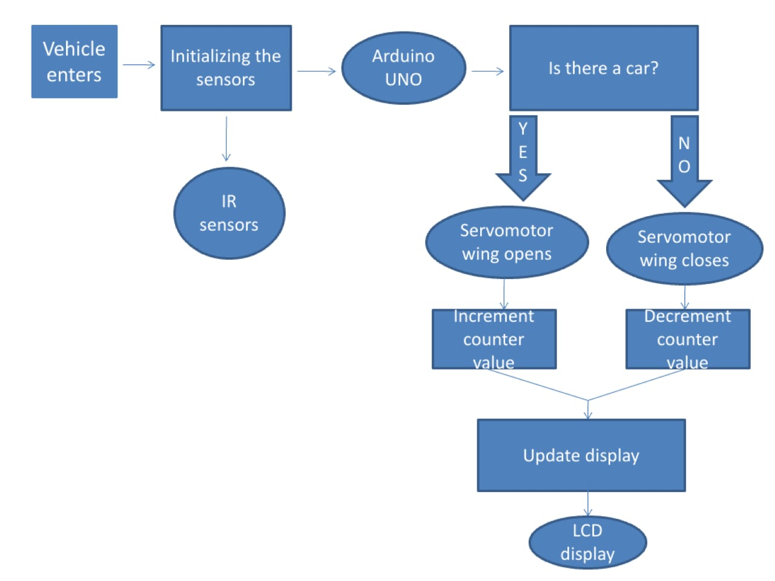 **3.1 Block Diagram:**

**3.2 GATE OPENING MECHANISM:** The input signal that needs to be processed is obtained in the form of infrared radiation and emits light after detecting the object which is in 100cm-500cm near the sensors. There is two sensors used here to detect entry and exit of the vehicles in the parking area. As IR SENSOR 1 detects the entry of an vehicle which helps in processing the information we need and leads to the operating of servo motor which eventually leads to the opening of gate which allows the vehicle to be parked inside. As it passes the IR SENSOR 2 it senses the servo motor to close the gate after vehicles enters the parking area. This gate opening mechanism that carried over with the motion of servomotor is initiated with the help of IR sensors , this also helps in displaying the information on LCD display.

**3.2HARDWARE USED:**

**3.2.1. ARDUINO UNO:**

The Arduino Uno is a microcontroller board based on the ATmega328P shown in figure 2.3. It has 14 digital input/output pins (of which 6 can be used as PWM outputs), 6 analog inputs, a 16 MHz quartz crystal, a USB connection, a power jack.

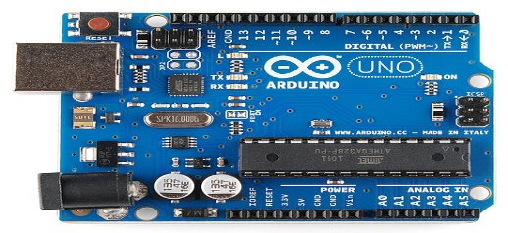

**Figure 3.2.1 Arduino Board**

**3.2.2. IR SENSOR**

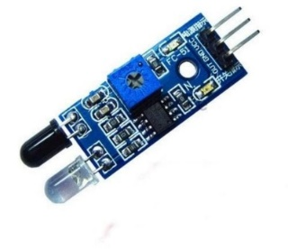Fig shows the IR sensor HW-201 module is used to sense the entry and exit of vehicle into the parking space.

**Figure 3.2.2 IR sensor**

**3.2.3 SERVOMOTOR**

A servo motor is an electrical device which can push or rotate an object with great precision. It rotates an object at some specific angles or distance. It is just made up of simple motor which run through servo mechanism which shown in figure 2.5

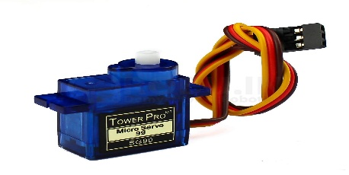.

**Figure 3.2.3 Servomotor**

If motor is used is DC powered then it is called DC servo motor, and if it is AC powered motor then it is called AC servo motor. Here, Servo motor is used to open the gate of the parking system.

**3.2.4 LITHIUM ION BATTERY**

A 3.7V Lithium ion battery is used to drive the moving components such as the servomotor, Arduino board and other sensors used.

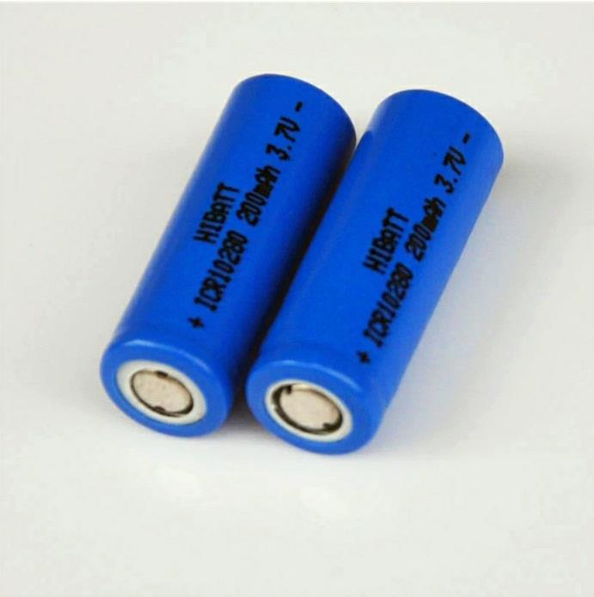

**Figure 3.2.4 9V Battery**

**3.2.5 LCD DISPLAY**

A LCD (Liquid Crystal Display) is a type of flat panel display which uses liquid crystals in its primary form of operation. Here we used to display number of parking slots left.

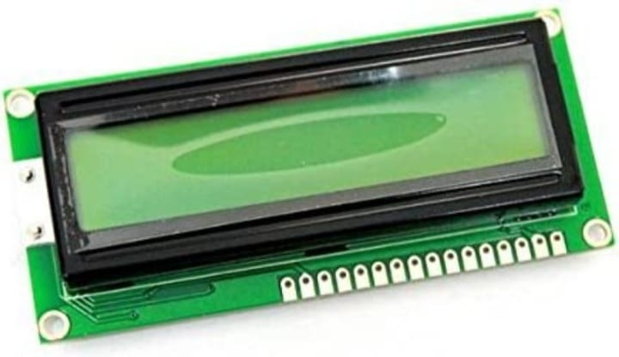 **Figure 3.2.5 LCD display (16*2)**

**IMAGE OF THE SMART PARKING SYSTEM MODEL**

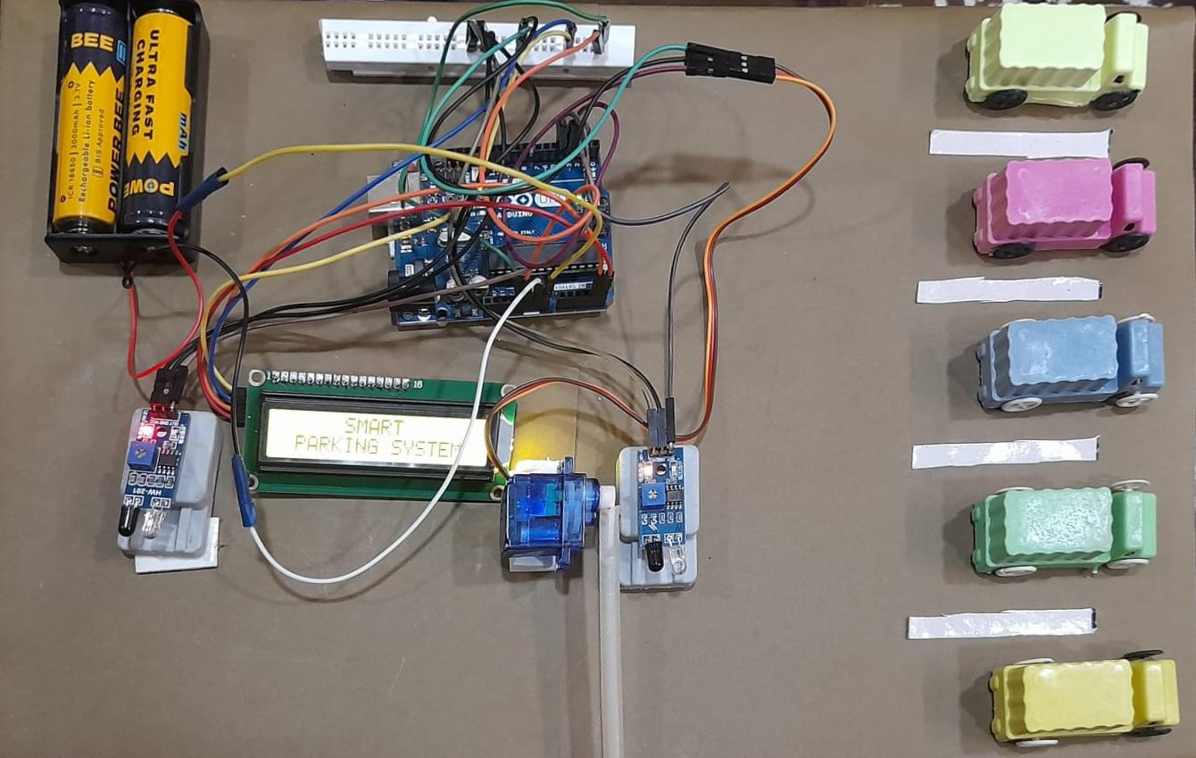

**SOFTWARE**

**4.0 SOFTWARE USED**

**4.0.1. ARDUINO UNO**

The application programmed is developed using Arduino IDE and Processing software.

The open-source Arduino Software (IDE) makes it easy to write code and upload it to the board. It runs on Windows, Mac OS X, and Linux. The environment is written in Java and based on Processing and other open-source software. This software can be used with any Arduino board.

**4.0.2. IDE (Integrated Development Environment)**

Processing is an open source programming language and integrated development environment (IDE) built for the electronic arts, new media art, and visual design communities with the purpose of teaching the fundamentals of computer programming in a visual context, and to serve as the foundation for electronic sketchbooks.

**5.RESULTS AND DISCUSSION**

Figure 5 shows the connection diagram of the sensors with Arduino microcontroller.

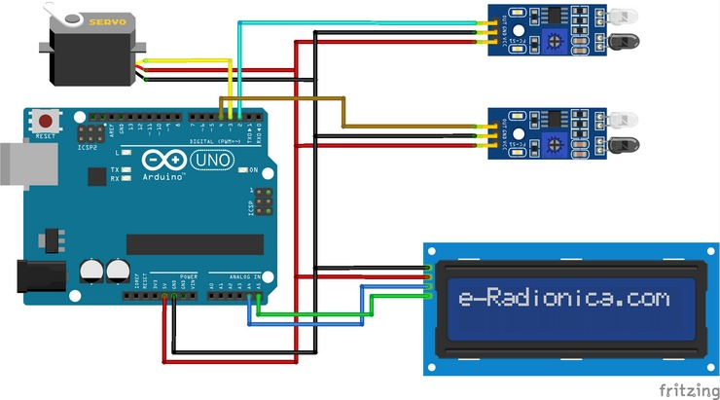

Figure 5.1 connection diagram of sensor with Arduino

The input signal that needs to be processed is obtained in the form of infrared radiation and emits light after detecting the object which is in 100cm- 500cm near the sensors. There is two sensors used here to detect entry and exit of the vehicles in the parking area. As IR SENSOR 1 detects the entry of an vehicle which helps in processing the information we need and leads to the operating of servo motor which eventually leads to the opening of gate which allows the vehicle to be parked inside. As it passes the IR SENSOR 2 it senses the servo motor to close the gate after vehicles enters the parking area. This gate opening mechanism that carried over with the motion of servomotor is initiated with the help of IR sensors , this also helps in displaying the information on LCD display.

**6.APPENDIX**

ARDUINO CODE: ( PROGRAMMING CODE )

#include <Wire.h>

#include <LiquidCrystal_I2C.h>

LiquidCrystal_I2C lcd(0x27,16,2); //Change the HEX address

#include <Servo.h>

Servo myservo1;

int IR1 = 2;

int IR2 = 4;

int Slot = 4; //Enter Total number of parking Slots

int flag1 = 0;

int flag2 = 0;

void setup() {

lcd.init();

lcd.backlight();

lcd.clear();

pinMode(IR1, INPUT);

pinMode(IR2, INPUT);

myservo1.attach(3);

myservo1.write(100);

lcd.setCursor (0,0);

lcd.print(" SMART ");

lcd.setCursor (0,1);

lcd.print(" PARKING SYSTEM ");

delay (3000);

lcd.clear();

}

void loop(){

if(digitalRead (IR1) == LOW && flag1==0){

if(Slot>0){flag1=1;

if(flag2==0){myservo1.write(0); Slot = Slot-1;}

}else{

lcd.setCursor (0,0);

lcd.print(" SORRY OUR ");

lcd.setCursor (0,1);

lcd.print("Parking Is Full ");

delay (4000);

lcd.clear();

}

}

if(digitalRead (IR2) == LOW && flag2==0){flag2=1;

if(flag1==0){myservo1.write(0); Slot = Slot+1;}

}

if(flag1==1 && flag2==1){

delay (1000);

myservo1.write(100);

flag1=0, flag2=0;

}

lcd.setCursor (0,0);

lcd.print(" WELCOME! ");

lcd.setCursor (0,1);

lcd.print("Slot Left: ");

lcd.print(Slot);

}

**REFERENCES**

**1**

International Journal of Scientific Research in

1. [GitHub - anmspro/Smart-Car-Parking-System: Smart Car Parking System using Arduino Uno.](https://github.com/anmspro/Smart-Car-Parking-System)
2. [Automatic car parking system project Using Arduino - Arduino Project Hub](https://create.arduino.cc/projecthub/Techatronic/automatic-car-parking-system-project-using-arduino-ba2cb8)
3. [smart parking system - arduino journal paper - Google Scholar](https://scholar.google.co.in/scholar?q=smart+parking+system+-+arduino+journal+paper&hl=en&as_sdt=0&as_vis=1&oi=scholart)
4. [(PDF) Smart Car Parking System using Arduino UNO (researchgate.net)](https://www.researchgate.net/publication/318486476_Smart_Car_Parking_System_using_Arduino_UNO)